Boeing XB-15 (XBLR-1 / Grandpappy) Long Range Heavy Bomber Prototype
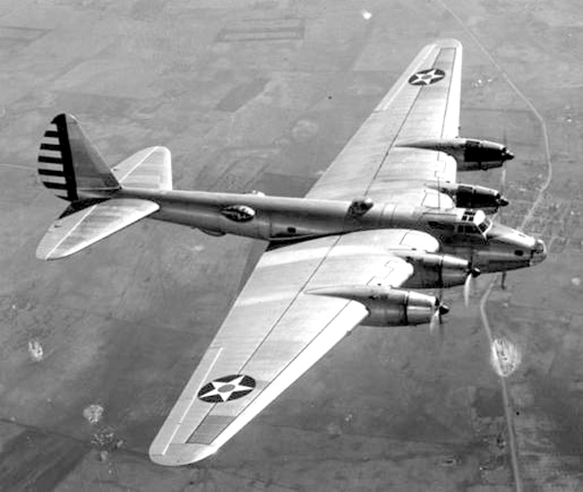

See Website; (https://www.militaryfactory.com/aircraft/detail.asp?aircraft_id=1080)

First flying in 1937, the Boeing XB-15 became the largest American-constructed bomber to that point.
In 1933, the United States Army Air Corps (USAAC) delivered a new specification for a heavy bomber with an inherent operational range of 5,000 miles and capable of a maximum speed of 200 miles per hour with a 2,000lb internal bomb load. The charge fell to both Boeing and Martin to which design work began in 1934. Boeing delivered its submission as the "XB-15" (Boeing Model 294) while Martin followed with the XB-16. The USAAC agreed to further the Boeing initiative and first flight of the prototype was achieved on October 15th, 1937 (the Martin design was never constructed, deemed too slow for the US Army requirement). However, the intended Allison V-3420 liquid-cooled inline piston engines of 1,000 horsepower were not yet ready and 4 x Pratt & Whitney R-1830-11 Twin Wasp radials of 850 horsepower were substituted instead. The original selection of inline engines was unique for many American aircraft of the period relied on air-cooled radial types.
The XB-15 was certainly a design ahead of its time which included its immense size - the largest aircraft ever built in the United States to that point. The design incorporated such features as an autopilot system to alleviate pilot workload on long flights, auxiliary power units as fail safes and wing deicers to protect against environmental factors during take-off. Internally, the wings were so voluminous that man-sized ducts were constructed that allowed technicians access to key components of the wings with the aircraft in flight. Due to the mission endurance required of the crew, bunk beds, a galley and a bathroom were all part of the internal arrangement of the XB-15. The complete crew complement numbered no fewer than ten personnel. The use of four engines also provided for an impressively wide-spanning wing assembly which gave the XB-15 its very identifiable top down profile.
Outwardly, the XB-15 was beginning to set the mold for more famous Boeing bomber designs to follow including the Boeing B-17 "Flying Fortress" and B-29 "Superfortress" of World War 2. The fuselage consisted of a tubular shape with the stepped flight deck fitted well-forward in the design, the nose capped by a "green house" style housing. The fuselage then tapered towards the rear to give the assembly its "tear drop" shape when viewed in the side profile. Wings were fitted high along the fuselage sides with each leading edge housing a pair of radial piston engines through forward-extended nacelles. These nacelles provided excellent views of the engines from each cockpit position. There proved glazed blisters along the aft sides of the fuselage for waist gunners or mission observers. The tail lacked a gun position as seen in the later B-17 and managed a single rounded vertical tail fin with a pair of low-mounted tail planes. The undercarriage consisted of a pair of two-wheeled main landing gear legs and a tail wheel which gave the design its pronounced "nose-up" appearance when at rest - a design arrangement to be utilized in future Boeing propeller-driven bombers.
The XB-15 was delivered to the 2nd Bombardment Group at Langley Field, Virginia and was pressed into humanitarian service in 1939 following an earthquake in Chile. The aircraft then underwent official bombing tests in Panama beginning in April. During the tests, accuracy proved elusive for less than 1% of dropped ordnance actually hit its mark. Several load-to-altitude records were then set by XB-15 crews in the period following - on July 30th, 1939, the XB-15 recorded a flight carrying a 31,205lb load up to an altitude of 8,200 feet. Officially (according to Boeing sources), the XB-15 was cleared for a combat ordnance load of up to 8,000lbs. Her final militarized form also included a defensive network of 3 x 0.30 caliber machine guns and 3 x 0.50 caliber heavy machine guns including one at her glazed-over nose. In 1940, the machine guns were removed when the aircraft arrived at Duncan Field, Florida.
With the United States entry into the war following the Japanese surprise attack on Pearl Harbor in December of 1941, the XB-15's future became a limited one as technological advancements overtook her once-evolutionary status. The B-17 was firmly entrenched at a primary bomber for the USAAF (as was the Consolidated B-24 Liberator) while the B-29 was nearing operational status - the latter soon to become its own technological marvel by war's end.
It was decided that the existing XB-15 airframe be converted as a dedicated cargo transport and, on May 6th, 1943, the aircraft was redesignated under the experimental "XC-105" classification. The fuselage was given a pair of cargo doors and an internal hoist system was installed to what would make the XC-105 become the air force equivalent of a pack mule. The aircraft served in this role until December 18th, 1944 before seeing her official retirement by the USAAF (United States Army Air Forces). With the end of the war in Europe by May 1945, the airframe of XB-15/XC-105 was ordered stripped and scrapped while based at Albrook Field in Panama. Her shell was dropped in a swamp near the airfield where she sank. During her active tenure, the XB-15 only served two US groups - the aforementioned 2nd Bombardment Group of the USAAC and the 20th Troop Carrier Squadron of the USAAF.
Work on the XB-15 went on to influence the proposed private venture Boeing Y1B-20 heavy bomber design of which two were ordered by the US Army in 1938. However, this order was quickly cancelled before physical work had begun. Nonetheless, Boeing's work on such heavy-class military bomber aircraft provided the know-how in the design, development and production of several key operational "heavies" for United States air power during World War 2 and beyond - even leading up to Boeing's involvement in commercial passenger flight.

Boeing XB-15 Technical Specifications:
Service Year: 1937
Type: Long Range Heavy Bomber Prototype
National Origin: United States
Manufacturer(s): Boeing Company - USA
Production Total: 1

Structural (Crew Space, Dimensions and Weights)
Operating Crew (Typical): 10
Overall Length: 87.60 feet (26.7 meters)
Overall Width: 149.05 feet (45.43 meters)
Overall Height: 18.08 feet (5.51 meters)
Weight (Empty): 37,787 lb (17,140 kg)
Weight (MTOW): 70,857 lb (32,140 kg)

Installed Power and Standard Day Performance
Propulsion: 4 x Pratt & Whitney R-1830-11 14-cylinder radial piston engines developing 850 horsepower each.
Maximum Speed: 197 mph (317 kph; 171 knots)
Maximum Range: 5,133 miles (8,260 km)
Service Ceiling: 18,898 feet (5,760 meters; 3.58 miles)

Armament / Mission Payload
STANDARD:
3 x 0.50 caliber Browning M2 heavy machine guns
3 x 0.30 caliber Browning M1919 machine guns
OPTIONAL:
Up to 8,000-12,000lbs of internal stores.

Global Operators / Customers
United States

Model Variants (Including Prototypes)
XB-15 ("Grandpappy") - Base Series Designation
XBLR-1 ("Experimental Bomber, Long-Range") - Limited-use designation.
Model 294 - Boeing Model Number
XC-105 - Experimental cargo transport conversion of original XB-15 airframe used operationally during World War 2.

